#### Tipping in the roll direction

Rationale for this calculation:

* Item 11.1 in the DMFEA rates tipping in the roll direction as a high RPN concern (54) until further explored
* Requirement 2.3 states that the chair is able to roll over an obstacle of at least 30cm with one wheel without tipping

The governing equation for roll tipping is derived from the FBD below

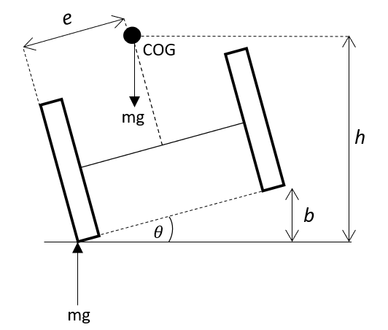

* The wheelchair tips when center of mass is vertical above the point of contact.
* This occurs when (1), where
  + e is the horizontal distance from the contact wheel to the center of mass
  + h is the vertical distance from the ground to the center of mass
  + θ is the roll angle from the ground
* The angle of the chair over a bump of size b is also a function of the width of the chair, 2e. $tanθ=b/2e$ (2)
* Combining equations (1) and (2), it follows that $2e^{2}/\sqrt{h^{2}-e^{2 }}=b$
* Given that the wheel diameter is 26” (66cm) and the center of mass is estimated to sit at 0.75*66 = 49.5cm above the ground, h = 49.5cm.
* Plugging in the previously stated values for b and h and using an equation solver gives e = 0.26m.
* Assuming that the COG is in the center of the width of the chair, 0.26*2 = **0.54m** is the minimum wheel width of our device to meet the established tipping requirement.
* 0.7m is chosen for comfort. This calculation also shows that tipping - a high severity failure mode - is of sufficiently low likelihood.
* In summary, Requirement 2.3 is met and the RPN of DFMEA item 11.1 has been reduced from 54 to 18.

#### Tipping in the pitch direction

Rationale for this calculation:

* Item 11.2 in the DMFEA rates tipping in the pitch direction as a high RPN concern (63) until further explored
* Requirement 2.4 states that the chair is able to roll over an obstacle of at least 30cm with one wheel without tipping

The governing equation for pitch tipping is derived from the FBD below

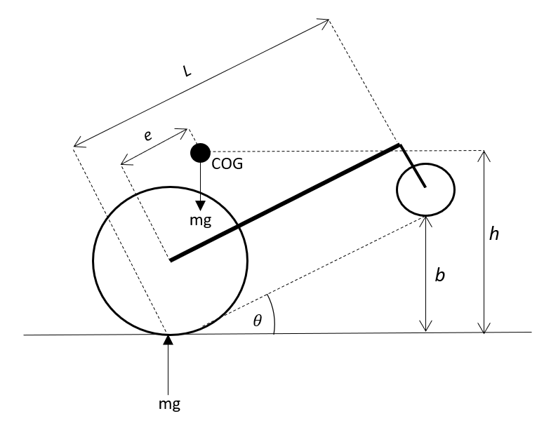

* The wheelchair tips when center of mass is vertical above the point of contact.
* This occurs when (1), where
  + e is the horizontal distance from the contact wheel to the center of mass
  + h is the vertical distance from the ground to the center of mass
  + θ is the roll angle from the ground
* The angle of the chair θ over a bump size *b* is a function of the length L of the chair, $b=Ltanθ$
* Based on the geometry of the chair and the anatomy of a person, assume that e = 0.2m.
* With h = 0.495m as above, θ = 24° based on equation (1)
* With b = 0.3m, L = 0.70m based on equation (2)
* Therefore, the minimum length of the chair to meet the tipping requirement is **0.70m**